

The Arab American University
Faculty of Engineering and Information Technology

Engineering Project Management (11071514)
Project Name:
Smart Hydroponic Greenhouse

Prepared by:
Tasneem Al-hwaiti 201811552
Hala Shahrour 201812099
Hala Jalouly 201811126

Instructor:
Eng Mohammad Tuffaha

June 2022 © Arab American University – Palestine

Introduction

Hunger and malnutrition issues still exist, especially in developing countries, hence the need to look for ways to increase food production and preserve plants.The greenhouse was one of these ways, which is the practice of producing food in vertically stacked layers. These “farms” make use of enclosed structures like warehouses and shipping containers to provide a controlled environment to grow crops in a hydroponic or aerologic system.
In our project we prefer to use a hydroponic vertical farm, the plants are grown in water instead of soil, allowing growers to provide nutrients directly to the root system of the plant and eliminating any soil degradation concerns. The water is then recycled through the system, again and again, meaning 98% less water uses than traditional farming, focusing on LESS LAND USAGE, LESS WATER USAGE, USES FEWER CHEMICALS.

Table of Contents

Introduction 2
Table of Contents 3
List of Table 5
Chapter One Project Pre-Initiation and Initiation 6
1.1 Overview 7
1.2 The business case for the project: 7
1.3 Project Stakeholders Register 12
Table 2: Stakeholders 12
1.4 Organizational Chart 13
1.5 Management Strategy 13
Table 3: managnent strategy 13
Chapter two Project Planning 15
2.1 Overview 16
2.2 Project Charter 16
Table 4: Roles and Responsibilities: 17
Professor 18
2.3 Kick-off Meeting 18
Table5 : The Project Kick-off Meeting: 19
2.4 Collecting Requirements 19
Nutrients 20
2.5 project scope statement 20
Project Justification: 21
2.6 Work Breakdown Structure (WBS) 22
2.7 WBS dictionary 23
2.8 Project Schedule 24
2.9 Project Budget/Financial Analysis 28
2.10 A list of prioritized risks 29
Power outage hazards 29
2.11 Milestone report 30
Chapter Three Project Execution 34
3.1 Overview 35
3.2 Performance /Progress Report 35
Chapter Four Project Monitoring and Controlling 37
4.1 Overview 38
4.2 Control Changes 38
4.3 Change Request 38
Chapter Five Project Closing 39
5.1 Overview 40
5.2 Lessons-learned report 40
5.3 Conclusion 42

List of Table
Table 1: The business case for the project: 7
Table 2: Stakeholders 12
Table 3: managnent strategy 13
Table 4: Roles and Responsibilities: 17
Table5 : The Project Kick-off Meeting: 19
Table 6: project statement 20
Table7: of prioritized Risks 29
Table 8: of Milestone: 30

Chapter OneProject Pre-Initiation and Initiation

LHamideh@bankofjordan.com.jo

1.1 Overview
More recently, hydroponics refers to the art of growing plants in water without soil (a land). The nutrients are supplied to plants to the roots in the form of a solution that can be Either in fixed or flowing form. Hydroponics can be grown in both greenhouses and houses vitreous. The limitation in the greenhouse environment is to maintain Temperature, pressure and humidity value at a certain level.

1.2The business case for the project:

Table 1: The business case for the project:
1.0 Introduction/ Background
In this project, we are drawing the attention of farmers who seek to increase the sustainability and productivity of their crops to implement advanced technologies into greenhouses agriculture in small areas. By a smart greenhouse that is built with the help of IOT intelligently monitors and controls the climate, eliminating the need for manual intervention.
That aim is to facilitate working, reduce the financial costs on the farm owner and lower labor requirements, which will return double profits for the farmer. Moreover, as the consumer who obtains various fresh varieties products all year round.
2.0 Business Objective
The main objective in our Hydroponic farm is grow produce year-round in a limited space by stacked plants on top of each other to make greater use of the entire space in water with no soil present.

Water efficient that uses 98% less water than traditional farming methods. By capturing and using water in a closed-system (and not allowing run off to drain into the environment) or recirculating water throughout the system, with no waste due to runoff or evaporation.
Plus, plants are able to grow faster and are less stressed due to less pest pressure by using water Which leads to uses fewer chemicals and Insecticides required to treat potential pests
In addition, using smart agriculture sensors to monitor the state of crops, they provide real-time information on critical climate factors including, temperature, humidity, light exposure and carbon dioxide across the greenhouse.
3.0 Current Situation and Problem/Opportunity Statement
The increase in population growth is accompanied by an increase in demand for food production. The world population will reach 9.73 billion by 2050, and the increase will continue until 11.2 billion by 2100. So, meeting rising demand for more food is the main problem. We have to deal with growing different crop varieties or even new crops with considering problems the lack of agricultural space lands, water shortage, and crop contamination.
4.0 Critical Assumption and Constraints
The farm should be built in a good and perfect way, including hydroponic vertical agriculture, providing the necessary and customized machinery, and monitoring the right conditions for crops. So, building a smart farm involves several challenges to meet high costs, so it takes a lot more effort to provide a better environment and strive to produce a much larger crop than farms that don't use technology to balance the budget required by these farms for equipment and conditions. The cost should not exceed the additional income it generates for the farmer.

5.0 Analysis of Option and Recommendation
There's many options and solutions such as:
Growing in high-tech greenhouses, avoiding strong dependence on the
Outdoor climate (using only artificial light).
Growing in high-tech greenhouses with plastic films as covering materials and insect-proof screens
Building a smart farm hydroponic vertically in a small area with a fully automated system but with trying to use the natural light of the sun as much as possible by increasing the roof slope from 11 to 45°
Maximizing the screened area, one method for increasing ventilation in multi-span greenhouses.
Smart farm horizontally in a very large area with a fully automated system.
carbon dioxide released into the air inside
regular watering

6.0 Preliminary Project Requirements
- Stacked plant racks and solution chambers.
2.Special purpose machines.
3.Water for the medium instead of soil.
4.Transplant.
5.Construction requirements.
6.Construction and electrical workers
7.Sensors, computers and routers
7.0 Budget Estimate and Financial Analysis
An estimate of costs for the entire project is 50,000$. This estimate is based on the project manager working about 40 hours per week for 7 month and other internal staff working a total of about 40 hours per week for 7 months. The project manager does not earn money at the beginning of the project, but an estimate of the profit in each season is 15,000, team members rent would be $20 per hour. The initial cost estimate also includes $50,000 for purchasing the sources and tools required for the project, without the cost of the land. After the project is accomplished, maintenance costs of $8,000 which we need to update the information, quality, techniques. Advertisement of greenhouse products through shops and the vegetable market, as well as through people on social media, at a cost of $100 per advertisement. It is expected that after the completion of the project, the maintenance costs will be $8,000 for each agricultural brand of all existing equipment and techniques and to increase the quality.

8.0 Schedule Estimate
The process of building greenhouses and connecting electronic devices takes the longest period. After the completion of the project, the plants need for a short period to grow in large quantities as a result of vertical farming.
- Potential Risks
1.Production Risks
- Marketing Risks
- Financial Risks
- Environmental Risks
- Damage and malfunction of hardware device
- Lack of experience as a result of starting the project for the first time
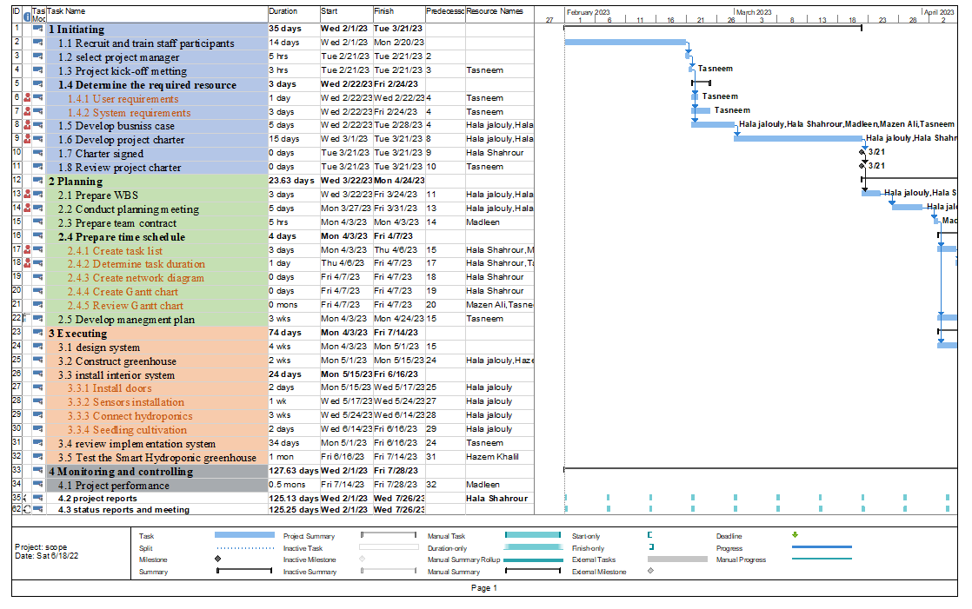
10.0 Exhibits

1.3 Project Stakeholders Register
Stakeholder Register for Project Name
Prepared by: Hala Jalouly Date: 2/1/2023

Table 2: Stakeholders
Role | Name |  |  |  |  | Internal/  External | Position | Contact Information
Sponsor |  |  | Administrator AlBayader Agricultural Trading Company |  |  | external | CEO | 0596792972
Accountant | Madleen |  |  |  |  | internal | Project employee | 0592781127
Sponsor | Mazen Ali |  |  |  |  | Internal | Vegetable shop owner | 0598979564
Programmer | Hala Shahrour |  |  |  |  | Internal | Team Member | h.shahrour@student.aaup.edu
Farmer | Hazem Khalil |  |  |  |  | Internal | Agricultural engineer | 0594783652
Project Manager | Tasneem Al-hwaiti |  |  |  |  | Internal | PM(Team member) | t.alhwaiti@student.aaup.edu
Hardware organizer | Hala Jalouly |  |  |  |  | Internal | Team Member | h.jalouly@student.aaup.edu
Adviser | Dr.Mohammad Tuffaha |  |  |  |  | External | Professor | Mohammad.Tuffaha@aaup.edu

1.4 Organizational Chart

Tasneem Al
-
hwaiti
(PM)
Hala Shahrour
(programmer)
Hazem Khalil
(farmer)
Hala Jalouly
(hardware organizer)
Madleen
(accountant)

1.5 Management Strategy

Table 3: managnent strategy
Name | Level of Interest | Level of  Influence |  | Potential Management Strategies
Tasneem Al-hwaiti | High | High | likes to stay on top of key projects and make money. Have a lot of short, face-to face meetings and focus on achieving the financial benefits of the project.
Hala Jalouly | High | High | excited to work this on this app, because she likes to be a member who help to reduce pollution
Hala Shahrour | High | High | thinks that this project maybe improves her abilities.
Madleen | Low | High | says she will work hard on this project to be success.
Hazem Khalil | Low | High | likes to work on this project to do something useful and help environment

Chapter two Project Planning

2.1 Overview
In this project, we will develop a farming system that uses hydroponic growing techniques, and where the plants are stacked on top of each other vertically to maximize growing space, in a controlled environment, which allows crops to be grown year-round in any part of the world, regardless of the conditions outside

2.2Project Charter
Project Title: Smart Hydroponic Greenhouse
Project Start Date: 1/2/2023 Projected Finish Date: 20/8/2023
Budget Information: Budget Information: We have the estimated budget in place before we begin the project, we estimate our project will cost nearly 50,000$. There are volunteers from outside the country if the project costs more than the budget. Our project budget includes the highest possible cost for hardware and software equipment if there will be any item damage or unavailability. Our contingency is 20% because computer hardware can be damaged due to the working environment or human errors.
Project Manager:
Project Objectives:
- Maintain Ideal Microclimate Conditions
- Enhance Irrigation and Fertilization Practices
- Control Infection and Avoid Disease Outbreak among plants
- The method of this cultivation prevails by providing larger areas and
Reducing our need for a large amount of water.
- Prevent Thefts and Improve Security
- Reducing the workforce.
- Sensing, monitoring and control the micro-climate measurements and environmental conditions of greenhouse prototype to create a smart hydroponic greenhouse for maximizing the food production as well as minimizing the ecological footprint under the climate change impacts, Coved 19 crisis, and natural resources shortages.
Main Project Success Criteria:
1.The project must be able to pay for itself within two years of its completion.
2.The project must be acceptable to shareholders and beneficiaries.
3.That the project fulfills the requirements of the shareholders and markets.
4.That project achieves the expected profits.
Approach:
- Determine the critical features and the requirements of the project.
- Develop software on mobile devices that support and control all devices found in these smart greenhouses far away.
- Divide the work required to implement the project throughout the project implementation period on all team members according to their specialization.
- Submit a document from each working member to evaluate their works and so that errors do not accumulate, if they exist.
- Follow the system of vertical farming through water during the entire project work period.
Roles and Responsibilities:

Table 4: Roles and Responsibilities:
Role | Name | Organization/  Position | Contact Information
Sponsor | Administrator AlBayader Agricultural Trading Company | complete  CEO | 0596792972
accountant | Madleen | Project employee | 0592781127
Sponsor | Mazen Ali | Vegetable shop owner | 0598979564
programmer | Hala Shahrour | Team Member | h.shahrour@student.aaup.edu
Farmer | Hazem Khalil | Agricultural engineer | 0594783652
Project Manager | Tasneem  al-hwaiti | PM  (Team member) | Tasneem.alhwaiti@gmail.com
Hardware organizer | Hala Jalouly | Team Member | h.jalouly@student.aaup.edu
Adviser | Dr. Mohammad Tuffaha | Professor | Mohammad.Tuffaha@student.aaup.edu

Sign-off:
Administrator al Bayader agricultural trading company
Madleen
Mazen Ali
Tasneem al-hwaiti
Hazem Khalil
Dr. Mohammad Tuffaha
Hala Jalouly
Hala Shahrour

2.3 Kick-off Meeting

Meeting Objective: Get the project off to a great start by introducing key stakeholders, reviewing project goals, and discussing future plans

Agenda:
- Introductions of attendees
- Background of project
- Review of project-related documents (i.e., business case, project charter)
- Discussion of project organizational structure
- Discussion of project scope, time, and cost goals
- Discussion of other important topics
- List of action items from meeting

Table5: The Project Kick-off Meeting:
Action Item | Assigned To | Due Date
Specific requirement | Hala Jalouly, Hazem Khalil | 1/2/2023
Project scope management | Sponsors, Hala shahrour, Dr. Mohammad Tuffaha | 1/2/2023
Estimate Project’s budget | Mazen Ali, Madleen, Tasneem al-hwaiti | 1/2/2023

Date and time of next meeting: 12/2/2023

2.4 Collecting Requirements

Requirement No. | Name | Category | Source | Status
R1 | Water | Material | Project Requirement | Complete
R2 | LED lights. | Hardware | Project Requirement | Complete
R3 | Pumps | Hardware | Project Requirement | Complete
R4 | Stacked plant racks | Hardware | Project Requirement | Complete
R5 | Sensors, computers and routers | Hardware | Project Requirement | In progress
R6 | Engineers | Human | Project Charter | Complete
R7 | Construction and electrical workers | Human | Project Requirement | Complete
R8 | Nutrients | Material | Project Requirement | Complete

2.5 project scope statement
Scope Statement (Version 1)

Table 6: project statement
Project Title: Smart Hydroponic Greenhouse Date: 1/2/2023
Prepared by: Tasneem Al-hwaiti

Project Justification:
We hope to achieve profits and good effort in order to obtain good crops at acceptable costs and achieve a wonderful and good type of modern agriculture, which is vertical farming in the water.
Product Characteristics and Requirements:
- Water is used to deliver the nutrients.
- Soil or potting mix is not used.
- organic crops can be grown
- plants will use significantly less water
- crops can be grown hyper-locally
- Uses fewer chemicals
- Lower labor requirements.
Summary of Project Deliverables
Project management-related deliverables: business case, charter, team contract, scope statement, WBS, schedule, cost baseline, status reports, final project presentation, final project report, lessons-learned report, and any other documents required to manage the project.
Product-related deliverables: research reports, design documents, software code, hardware, etc.
Examine the need of agricultural economy to this technique, it’s effect on increasing crop production, and how many farmers will use it
Instructions for how to use this technique.
hardware tools like Sensors, computers, led, pumpsand routers.
Project Success Criteria:
1.Trying to make the most of hydroponic farming
2.Complete the project on time and at the required cost
3.Achieving good profits and returns

2.6 Work Breakdown Structure (WBS)
Prepared by: Hala Jalouly Date: 10/1/2023
1. Initiating
  - Recruit and train staff participants.
  - Select project manager.
  - Determine the required resource.
1.3.1 User requirements.
1.3.2 System requirements.
1.4 Develop business case.
1.5 Develop project charter.
1.6 Charter signed.
1.7 Review project charter.
1.8 Project kick-of meeting.

2. Planning
2.1 Prepare WBS
2.2 Conduct planning meeting
2.3 Prepare team contract
2.4 Prepare time schedule
2.4.1 Create task list
2.4.2 Determine task duration
2.4.3 Create network diagram
2.4.4 Create Gantt chart
2.4.5 Review Gantt chart
2.5 Develop management plan
2.5.1 Develop management risk

3. Executing
3.1 Construct green house.
3.2 Implementation system.
3.3 Construct walls and roof.
3.3.1 Install doors.
3.3.2 Install interior system.
3.4 Sensors installation.
3.5 Connect hydroponics.
3.6 Seedling cultivation.
3.7 Test the Smart Hydroponic greenhouse.

4. Monitoring and controlling
4.1 Project performance.
4.2 Project reports.
4.3 Status reports and meeting.
5. Closing
5.1 Final report
5.2 Prepare final representation
5.3 Lessons learned

2.7 WBS dictionary
WBS that conveys detailed info about each component. It’s one of the five pillars that support the scope management in your project
These five components will give you the scope baseline for your project. Without a project scope baseline, you can’t measure performance effectively, which puts your project in danger of going off schedule and beyond budget.
the details of the tasks, activities, and deliverables of the work breakdown structure are located. The content includes whatever milestones are related, the project scope and in some instances dates, resources, cost and quantity.
Work Breakdown Structure Template for Project Name: Smart Hydroponic Greenhouse.

2.8 Project Schedule
in the form of a Gantt chart with all dependencies and resources entered and Network Diagram.
MS project- Gantt chat

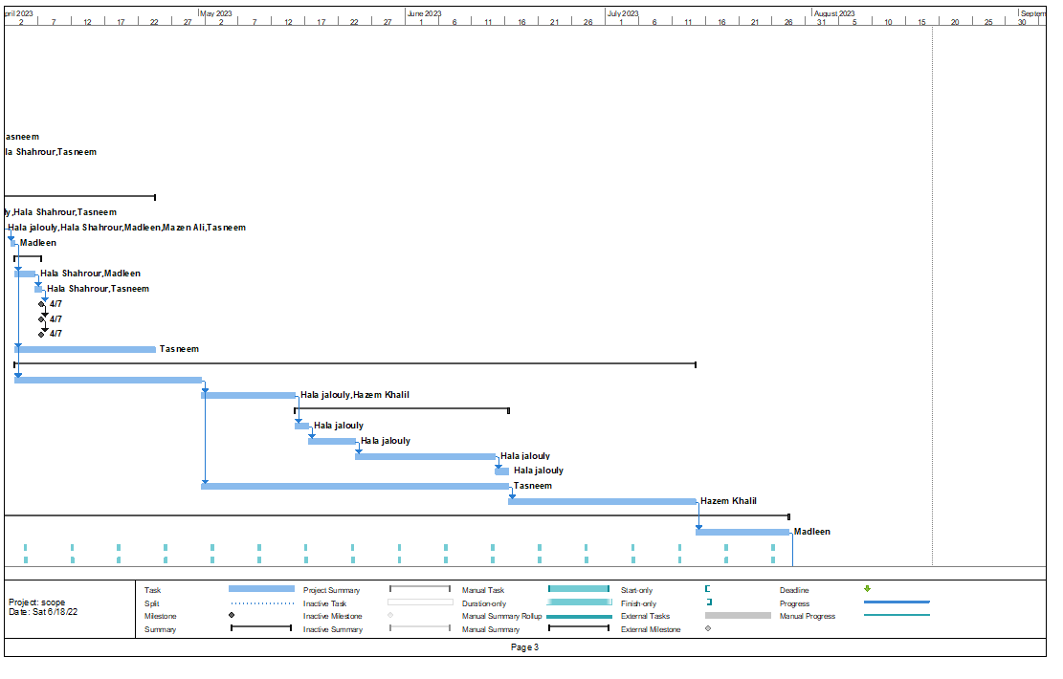

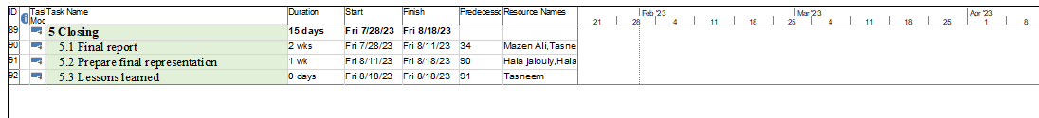

Network diagram

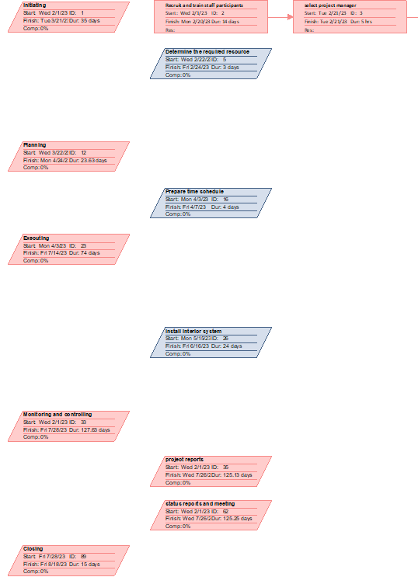

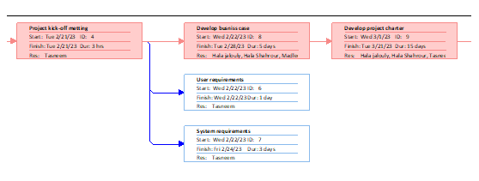

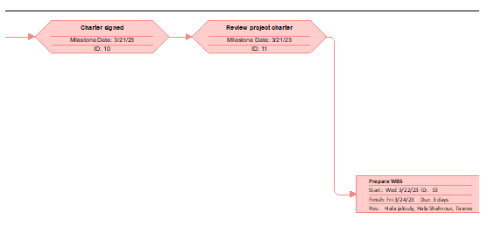

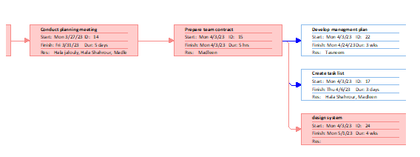

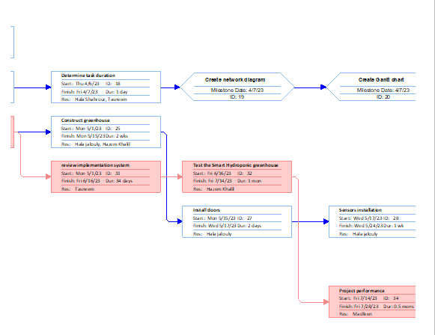

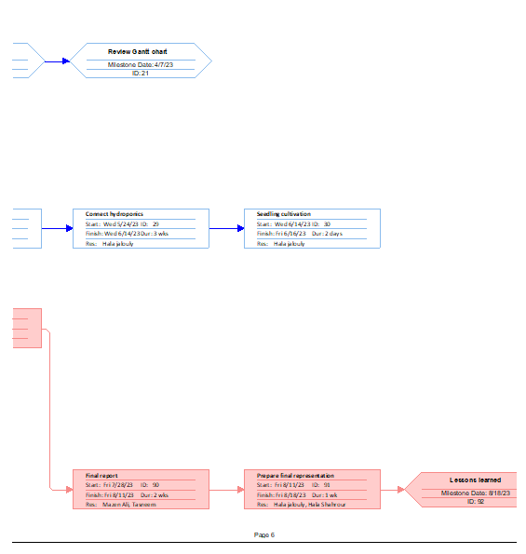

2.9 Project Budget/Financial Analysis
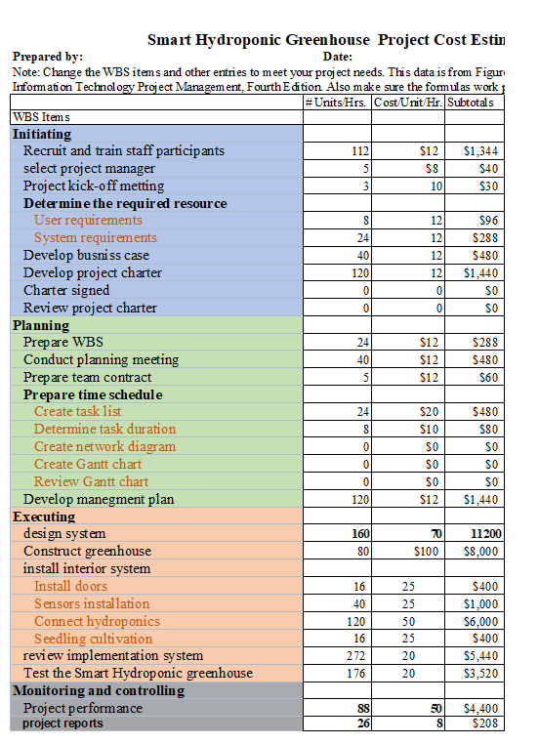

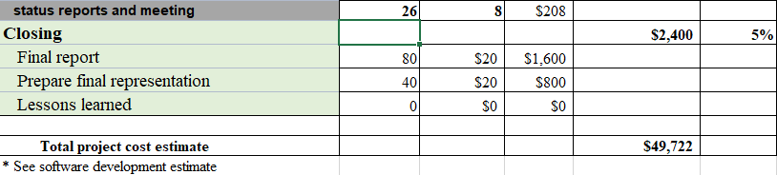

Discount rate 5%
 | Year0 | Year1 | Year2 | Year3 | Year4
Benefits | 0 | 10000 | 20000 | 35000 | 40000
cost | 50000 | 5000 | 5000 | 5000 | 5000
Cash flow | -50000 | 5000 | 15000 | 30000 | 35000
NPV | 23077
Outflow | 67729
ROI | 34%
PBP | YEAR4

2.10 A list of prioritized risks
List of Prioritized Risks for Smart Hydroponic Greenhouse
Prepared by: Hala Shahrour Date: 15/2/2023

Table7: of prioritized Risks
Ranking | Potential Risk
1 | Power outage hazards
2 | Temperature and humidity
3 | High upfront costs
4 | Pollination problems
5 | Freezing hazards
6 | Significant maintenance efforts
7 | Waterborne diseases
8 | Technology issues may cause huge problems

2.11 Milestone report
This report is dedicated to the Smart Hydroponic Greenhouse project carried out by a group of female students from the Arab American University. This report describes information about the project and how it operates in the field of agriculture.
The end result of this project will be the creation of a brilliant application connected with devices connected to the greenhouses to achieve the goal of the project in an excellent manner
- Milestone Report for Project Name: Smart Hydroponic Greenhouse

Prepared by: Hala Jalouly Date: 9/2/2023

Table 8: of Milestone:
Milestone | Date | Status | Responsible | Issues/Comments
project charter | 1/2/2023 | Not finish | Team member | Its completion depends on the stages of completion of the project
Hold first team meeting. | 31/1/2023 | completed | Team member,  Tasneem manager | The date for the second meeting has been set 12/2/2023
Obtain bids | 31/1/2023 | completed | Sponsors, Madleen | ____________
Buying required hardware | 18/2/2023 | completed | Hala  Hala  Dr. Mohammad | ____________
Create simple floor plan noting locations of doors and any interior walls. | 9/2/2023 | completed | professional workers | ___________
Construct green house | 18/2/2023 | Not finish | professional workers,  Tasneem | It is completed in several stages
Construct walls and roof. | 2/3/2023 | completed | professional workers | ___________
construct doors | 2/3/2023 | completed | professional workers | __________
Install interior system. | 3/3/2023 | Hala,  Hala | completed | ___________
Sensor’s installation | 15/3/2023 | completed | Hala  Hala | Sensitive work and accurate
Connect hydroponics | 23/3/2023 | Hazem Khalil, Hala  , Hala | Complete 80% | It was postponed to see the quality of the implant
buy seedlings | 4/4/2023 | Hazem Khalil | completed | ___________
Seedling cultivation | 6/4/2023 | Hazem Khalil, professional worker | completed | ____________
Complete Connect hydroponics | 14/4/2023 | Hazem Khalil,  Hala  Hala | completed | __________
Monitor the growth of fruits | 15/4/2023  For one month | Hazem Khalil | Not finish | _________
Monitoring and controlling | Every week | Tasneem  Hala  Hala | Not finish | ____________
Income | For each season | Madleen | Not the time | ___________

Chapter Three Project Execution

3.1 Overview
In this part, we carry out the activities related to the project on time as much as possible, and write what has been completed and the activities that have not yet been completed

3.2 Performance /Progress Report

Project Name: Smart Hydroponic Greenhouse.
Team Member Name: Tasneem Alhwaiti, Hala Jalouly, Hala Shahrour
Date: 30/1/2023.
Reporting Period: 1/2/2023 – 20/8/2022.
Work completed this reporting period:
During this period, all the activities in WBS that were planned have been completed.

Work to complete next reporting period:
After you have finished planting the seedlings that have been completed in the period of this report, it will be waiting until all the seedlings sprout and give the required fruits through the equipped and tied techniques that have been completed and then harvested with special tools equipped for this process. The product is taken by the Sponsor

What’s going well and why:
The project implementation steps go very well and every step is examined before it is implemented.

What’s not going well and why:
Additional time and intensive meetings may be required, we faced a challenge in finding hardware devices in our country, and it took some time to get it to us

Suggestions/Issues:
Holding meetings with experts and searching for additional resources, the used equipment and confiscation must be reserved a period before the start of the project to reach the required date.
Project changes
I believe that all steps need to be precise to avoid errors and problems, we change the type of fruits to suit the quality and technology of our farming.

Chapter Four Project Monitoring andControlling

4.1 Overview
Monitoring and controlling is the process of measuring progress toward project objectives,monitoring deviation from the plan, and taking corrective action to match progress with the plan. Monitoring and controlling is done throughout the life of a project.
Use a Work Breakdown Structure (WBS) to break a project down into small units of work, sub-tasks. This makes the work easier to manage and evaluate. This enables easier detection of issues, keeps the project under control and allows for easier progress verification. It also helps prevent team members from feeling overwhelmed.

Control Changes
- View project management as a process of constant communication and negotiation.
- Plan for change.
- Establish a formal change control system, including a change control board (CCB). Use effective configuration management.
- Define procedures for making timely decisions on smaller changes.
- Use written and oral performance reports to help identify and manage change.
- Use project management and other software to help manage and communicate changes.
- Focus on leading the project team and meeting overall project goals and expectations

4.3 Change Request

We submit a change request and according to change control system and change control board(CCB) it approving or rejecting.We submitted a request to change the sensors and pumps for a better quality.

Chapter Five Project Closing

5.1 Overview

Closing the project means completing all project phases and steps and reaching goals and plans that were previously agreed upon, and new proposals, if any.

5.2 Lessons-learned report

Prepared by: Date:29/1/2023
Project Name: Smart Hydroponic Greenhouse
Project Sponsor: Administrator Al Bayader Agricultural Trading Company
Project Manager: Tasneem Alhwaiti
Project Dates: 1/2/2023 - 20/8/2022
Final Budget: 49,722$
1.Did the project meet scope, time, and cost goals?
Yes, it was almost done

2.What was the success criteria listed in the project scope statement?

As it is said: (necessity is the mother of invention), so this was the most important reason in designing this projectit was because of the need to increase production and save space.
We tried to plant the largest possible number in a vertical way to make great use of the spaces and increase productivity.

3.Reflect on whether or not you met the project success criteria.
Good planning and having the skills and experience of team members is one ofthe most important criteria that appears in the project and that leads us to great success

4.In terms of managing the project, what were the main lessons your team learned?
- Choose people based on their experience
- Allocate tasks correctly
- Respect time

5.Describe one example of what went right on this project.
Cooperation is very important and simplify the tasks to accomplish the largest possible number of tasks

6.Describe one example of what went wrong on this project.
The time was approximated at the beginning, then it turned out that we need more time and the cost is a little more than we expected

7.What will you do differently on the next project based on your experience working on this project?
We have become more knowledgeable about time organization and its importance and how to think about successful projects

5.3 Conclusion
The purpose of the closing phase in the project management lifecycle is to confirm completion of project deliverables to the satisfaction of the project sponsor, and to communicate final project disposition and status to all participants and stakeholders.

